1-Vendor Folder

📁 What Is the vendor/ Folder in PHP (Composer)?
# Source: AI Source: Provided by: [Data Path: Persons Table -> ID Column: 1, Name_En Column: Motasem Essam] -> From: [Chatgpt (GPT‑5 Mini)] on [1/26/2026]
The vendor/ folder is automatically created by Composer and contains:
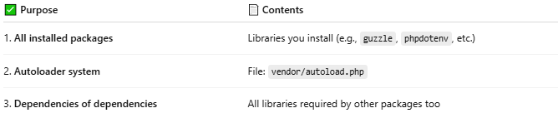
✅ Purpose | 📄 Contents
1. All installed packages | Libraries you install (e.g., guzzle, phpdotenv, etc.)
2. Autoloader system | File: vendor/autoload.php
3. Dependencies of dependencies | All libraries required by other packages too

🧪 Example Contents of vendor/:
# Source: AI Source: Provided by: [Data Path: Persons Table -> ID Column: 1, Name_En Column: Motasem Essam] -> From: [Chatgpt (GPT‑5 Mini)] on [1/26/2026]
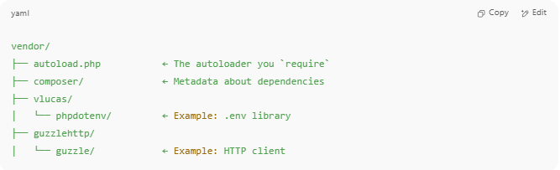
vendor/
├── autoload.php ← The autoloader you `require`
├── composer/ ← Metadata about dependencies
├── vlucas/
│ └── phpdotenv/ ← Example: .env library
├── guzzlehttp/
│ └── guzzle/ ← Example: HTTP client

✅ Why vendor/ Is Important
# Source: AI Source: Provided by: [Data Path: Persons Table -> ID Column: 1, Name_En Column: Motasem Essam] -> From: [Chatgpt (GPT‑5 Mini)] on [1/26/2026]
- It contains the code for every installed PHP package
- It holds the Composer autoloader, so you can do:
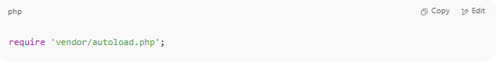
require 'vendor/autoload.php';

- It makes your app modular, so you don’t need to manually include library files

🚫 Do Not Edit vendor/ Yourself
# Source: AI Source: Provided by: [Data Path: Persons Table -> ID Column: 1, Name_En Column: Motasem Essam] -> From: [Chatgpt (GPT‑5 Mini)] on [1/26/2026]
- It’s managed by Composer
- You should never change files manually inside it
- It can always be rebuilt using:
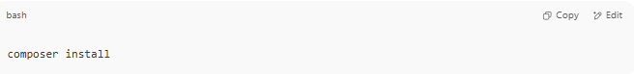
composer install

🧩 Diagram: How vendor/ and autoload.php Work Together
# Source: AI Source: Provided by: [Data Path: Persons Table -> ID Column: 1, Name_En Column: Motasem Essam] -> From: [Chatgpt (GPT‑5 Mini)] on [1/26/2026]
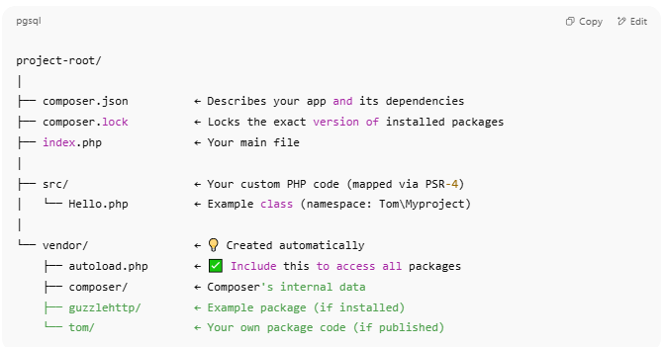
project-root/
│
├── composer.json ← Describes your app and its dependencies
├── composer.lock ← Locks the exact version of installed packages
├── index.php ← Your main file
│
├── src/ ← Your custom PHP code (mapped via PSR-4)
│ └── Hello.php ← Example class (namespace: Tom\Myproject)
│
└── vendor/ ← 💡 Created automatically
├── autoload.php ← ✅ Include this to access all packages
├── composer/ ← Composer's internal data
├── guzzlehttp/ ← Example package (if installed)
└── tom/ ← Your own package code (if published)

📦 Flow:
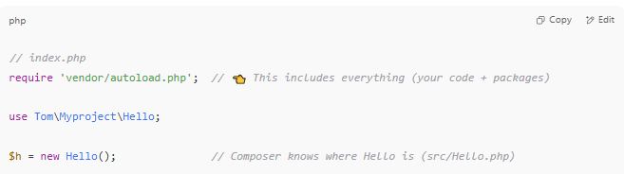
// index.php
require 'vendor/autoload.php'; // 👈 This includes everything (your code + packages)

use Tom\Myproject\Hello;

$h = new Hello(); // Composer knows where Hello is (src/Hello.php)

Recommended .gitignore File
# Source: AI Source: Provided by: [Data Path: Persons Table -> ID Column: 1, Name_En Column: Motasem Essam] -> From: [Chatgpt (GPT‑5 Mini)] on [1/26/2026]
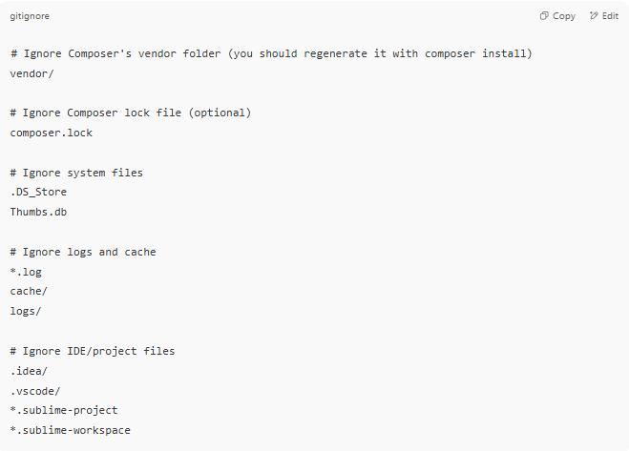
# Ignore Composer's vendor folder (you should regenerate it with composer install)
vendor/

# Ignore Composer lock file (optional)
composer.lock

# Ignore system files
.DS_Store
Thumbs.db

# Ignore logs and cache
*.log
cache/
logs/

# Ignore IDE/project files
.idea/
.vscode/
*.sublime-project
*.sublime-workspace

✅ This .gitignore ensures you don’t commit third-party libraries (like vendor/) to your Git repository — only your code goes in.

🧾 Summary
# Source: AI Source: Provided by: [Data Path: Persons Table -> ID Column: 1, Name_En Column: Motasem Essam] -> From: [Chatgpt (GPT‑5 Mini)] on [1/26/2026]
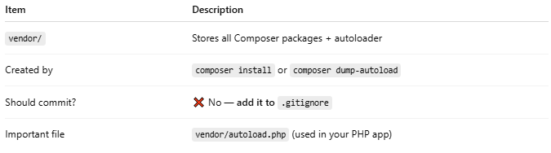

Item | Description
vendor/ | Stores all Composer packages + autoloader
Created by | composer install or composer dump-autoload
Should commit? | ❌ No — add it to .gitignore
Important file | vendor/autoload.php (used in your PHP app)

2-src folder

📁 What Is the src/ Folder in PHP Projects?
# Source: AI Source: Provided by: [Data Path: Persons Table -> ID Column: 1, Name_En Column: Motasem Essam] -> From: [Chatgpt (GPT‑5 Mini)] on [1/26/2026]
The src/ folder stands for "source", and it’s a convention (not required) for organizing your own application’s code — such as classes, interfaces, traits, and business logic.

🧩 Typical Usage
# Source: AI Source: Provided by: [Data Path: Persons Table -> ID Column: 1, Name_En Column: Motasem Essam] -> From: [Chatgpt (GPT‑5 Mini)] on [1/26/2026]
When using Composer with PSR-4 autoloading, your composer.json may look like:
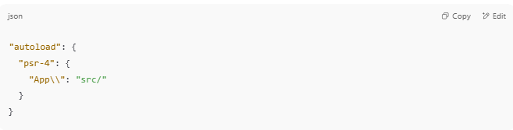
"autoload": {
"psr-4": {
"App\\": "src/"
}
}

This tells Composer:
“Classes in the App\ namespace are located inside the src/ folder.”

🧱 Example Project Structure
# Source: AI Source: Provided by: [Data Path: Persons Table -> ID Column: 1, Name_En Column: Motasem Essam] -> From: [Chatgpt (GPT‑5 Mini)] on [1/26/2026]
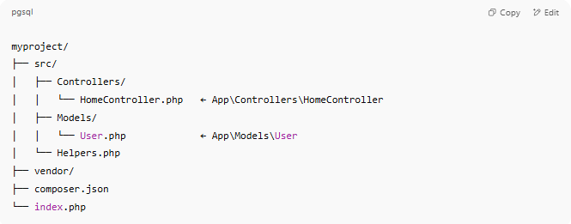
myproject/
├── src/
│ ├── Controllers/
│ │ └── HomeController.php ← App\Controllers\HomeController
│ ├── Models/
│ │ └── User.php ← App\Models\User
│ └── Helpers.php
├── vendor/
├── composer.json
└── index.php

📄 Example Class in src/
# Source: AI Source: Provided by: [Data Path: Persons Table -> ID Column: 1, Name_En Column: Motasem Essam] -> From: [Chatgpt (GPT‑5 Mini)] on [1/26/2026]
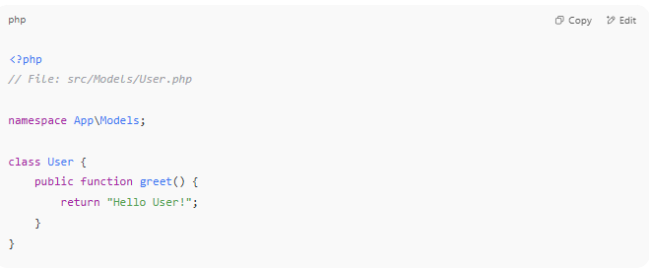
<?php
// File: src/Models/User.php

namespace App\Models;

class User {
public function greet() {
return "Hello User!";
}
}

You can use it in index.php like:
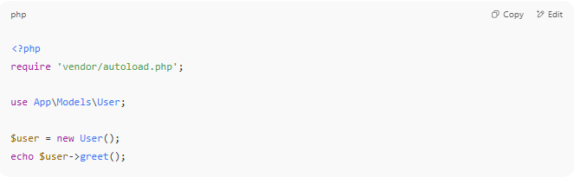
<?php
require 'vendor/autoload.php';

use App\Models\User;

$user = new User();
echo $user->greet();

✅ Why Use src/?
# Source: AI Source: Provided by: [Data Path: Persons Table -> ID Column: 1, Name_En Column: Motasem Essam] -> From: [Chatgpt (GPT‑5 Mini)] on [1/26/2026]
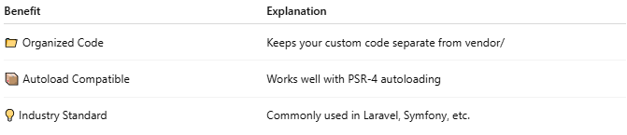

Benefit | Explanation
📁 Organized Code | Keeps your custom code separate from vendor/
📦 Autoload Compatible | Works well with PSR-4 autoloading
💡 Industry Standard | Commonly used in Laravel, Symfony, etc.

🔍 Summary
# Source: AI Source: Provided by: [Data Path: Persons Table -> ID Column: 1, Name_En Column: Motasem Essam] -> From: [Chatgpt (GPT‑5 Mini)] on [1/26/2026]
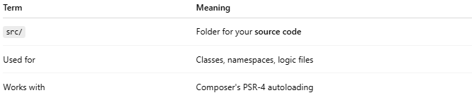

Term | Meaning
src/ | Folder for your source code
Used for | Classes, namespaces, logic files
Works with | Composer's PSR-4 autoloading

